How to Add Articles to Existing Publication without full Re-Initialization

* Create your publication as per normal

Initialize your subscriber with the snapshot



When it comes time and you want to add a new article to the publication but you don’t want to re-initialize all articles:

Before :

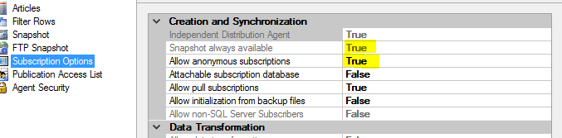

Run the following in the publication Database:

-- Set this false first

Exec sp_changepublication

@publication='WWImporters_1',

@property='allow_anonymous',

@value='false'

Go

Exec sp_changepublication

@publication='WWImporters_1',

@property='immediate_sync',

@value='false'

Go

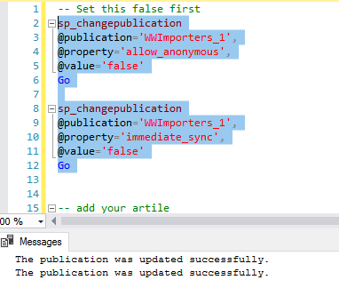

After:

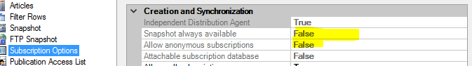

-- add your article(s) – here I added 4 , so new snapshot should be 6 articles

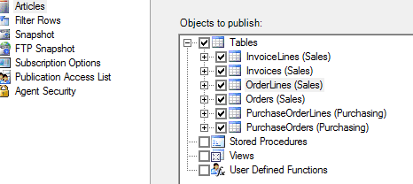

-- run snapshot agent (notice you only generate articles for newly added objects)



-- reset publication settings to defaults

sp_changepublication

@publication='WWImporters_1',

@property='immediate_sync',

@value='true'

Go

sp_changepublication

@publication='WWImporters_1',

@property='allow_anonymous',

@value='true'

Go

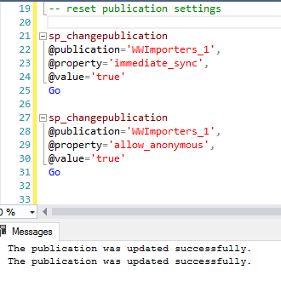

After :



-- run snapshot agent again - notice you now get all selected articles



